

MALL CUSTOMER CLUSTERING ANALYSIS
Done by,
Ganga Sowmya Devi R
Kaushik S
Kaviya R
TABLE OF CONTENTS
S.NO | CONTENTS | PAGE NO
1 | INTRODUCTION | 1
2 | OBJECTIVE | 1
3 | KEY METRICS USED | 2
4 | DATASET OVERVIEW | 2
5 | DATA PRE-PROCESSING | 2
6 | EXPLORATORY DATA ANALYSIS | 2
7 | CLUSTERING APPROACH(K-MEANS) | 3
8 | INSIGHTS AND FINDINGS | 4
9 | SUPPORTING VISUALS | 6
10 | LIMITATIONS | 6
11 | RECOMMENDATIONS | 8
12 | CONCLUSION | 8

MALL CUSTOMER CLUSTERING ANALYSIS
- INTRODUCTION
Customer segmentation is an essential technique used by businesses to understand their customers better and tailor strategies for improved marketing, sales, and service delivery. In this project, mall customers are analysed using demographic factors such as age, gender, and annual income, along with behavioural patterns captured through spending scores. By applying the K-Means clustering algorithm, the study aims to identify meaningful customer groups with similar characteristics. These segments help businesses understand purchasing behaviour, personalize marketing campaigns, and enhance overall customer satisfaction.

- OBJECTIVE
- To group mall customers into distinct segments based on demographic and spending attributes.
- To analyse customer behaviour using factors such as age, annual income, and spending score.
- To apply K-Means clustering for identifying meaningful patterns within the customer dataset.
- To provide insights that help businesses design targeted and effective marketing strategies for each customer group.
- To support data-driven decision-making by understanding how different customer types contribute to mall revenue and engagement.

3. KEY METRICS USED
The dataset includes several business-critical metrics commonly used in customer segmentation, marketing analytics, and mall footfall analysis.
Key metrics include:
🔹 Demographic Metrics
- Age – used for segmentation into Customer Age Groups.
- Gender – helps analyze spending patterns and buying behavior.
🔹 Financial Metrics
- Annual_Income_k$ – indicates spending potential.
- Total_Amount_Spent – cumulative expenditure by the customer.
- Spending_Score (1–100) – a normalized rating representing spending behavior.
🔹 Behavioural Metrics
- Visit_Frequency – number of visits contributing to customer value.
- Avg_Time_Spent_Min – time spent inside the mall (engagement indicator).
- Num_Returns – product return behavior affecting profitability.
- Last_Visit_Days_Ago – recency indicator useful for churn analysis.
- Preferred_Day – weekly footfall preferences.
🔹 Loyalty & Marketing Metrics
- Loyalty_Member (Yes/No) – presence in loyalty ecosystem.
- Marketing_Opt_In (Yes/No) – eligible for targeted marketing offers.
- Payment_Method – customer payment preference (Card, UPI, Wallet).
These metrics together allow:
- Customer segmentation
- RFM analysis
- Targeted marketing campaigns
- Predicting customer churn
- Behavioral clustering

4. DATASET OVERVIEW
📁 Dataset Shape
- Rows: 5,000 customers (as inspected in head sample)
- Columns: Multiple demographic, financial, and behavioral attributes.
📌 Sample Columns Explained
Column Name | Description
CustomerID | Unique ID of each customer
Gender | Male/Female
Age | Numeric age
Age_Group | Categorized into Young Adult, Adult, Senior
Annual_Income_k$ | Customer yearly income in $1000s
Spending_Score | Derived metric (1–100)
Visit_Frequency | Number of mall visits per month or quarter
Avg_Time_Spent_Min | Avg time spent inside the mall
Preferred_Day | Common day of visit: Weekday/Weekend
Payment_Method | UPI, Card, Wallet
Loyalty_Member | Whether they are part of loyalty program
Total_Amount_Spent | Lifetime spend
Num_Returns | No. of returns by customer
Marketing_Opt_In | Consented to marketing
Last_Visit_Days_Ago | Recency metric

🧾 General Observations
- Dataset is customer-level and appears to be fully synthetic but realistic.
- Includes both categorical and numeric variables.
- Suitable for clustering (KMeans), RFM analysis, segmentation, and predictive modeling.

5. DATA PREPROCESSING
Before performing analysis, the following preprocessing steps are recommended:
✔️ Missing Value Handling
- Checked the dataset: no missing values were detected in the sample preview.
- If any exist, handle via:
  - Mean/median imputation for numeric
  - Mode imputation for categorical
✔️ Data Type Validation
- Convert categorical variables:
  - Gender
  - Age_Group
  - Preferred_Day
  - Payment_Method
  - Loyalty_Member
  - Marketing_Opt_In
- Ensure date-like values (if any) follow a uniform format.
✔️ Feature Encoding
For ML tasks:
- Label Encoding for binary columns:
  - Loyalty_Member
  - Marketing_Opt_In
- One-Hot Encoding for:
  - Payment_Method
  - Gender
  - Age_Group
✔️ Outlier Treatment
Numeric columns to check for outliers using boxplots/IQR:
- Annual_Income_k$
- Spending_Score
- Total_Amount_Spent
- Avg_Time_Spent_Min
✔️ Scaling of Features
Models like KMeans, PCA require scaling:
- StandardScaler or MinMaxScaler for:
  - Annual_Income_k$
  - Spending_Score
  - Visit_Frequency
  - Avg_Time_Spent_Min
  - Total_Amount_Spent
✔️ Feature Engineering
You can create useful features such as:
- Income-to-Spending Ratio
- Engagement Score (based on time spent + visit frequency)
- Recency Flag (Active/Inactive)
- Return Rate (Num_Returns divided by visits or purchases)
6. Exploratory Data Analysis (EDA) Report
This EDA summarizes key demographic and behavioral characteristics of mall customers using visual insights from gender distribution, age segmentation, income distribution, and spending behavior.

1. Gender Distribution (Treemap)
Key Insights:
- The customer base is almost perfectly balanced:
  - Male: 2504 customers (50.1%)
  - Female: 2496 customers (49.9%)
- Such near-equal representation ensures unbiased customer segmentation across gender.
- Marketing strategies do not need gender-specific weighting since both demographics are equally present.
Business Implication:
- Campaigns (e.g., promotions, loyalty offers) can be designed as gender-neutral, ensuring equal reach.
- Gender patterns in spend or frequency (if analyzed further) can reveal targeted micro-segments.

2. Age Group Distribution (Bar Chart)
Age Category Counts (from the chart):
- Senior – Highest population (~1800)
- Middle Age – Second highest (~1400)
- Adult – Moderate (~1000)
- Young Adult – Lowest (~700)
Key Insights:
- Senior customers form the largest segment in the dataset.
- Young Adults are the smallest group, possibly due to lower purchasing power or mall preference.
- Middle-aged customers maintain strong representation, showing balanced participation.
Business Implication:
- Seniors may require comfort-oriented promotions: healthcare, lifestyle products, food courts.
- Young Adults may respond to trendy fashion, entertainment, and digital promotions.
- Age-based personalization can significantly increase conversion rates.

3. Annual Income Distribution (Histogram + KDE)
Observations:
- Annual income values appear uniformly distributed across the range (approx. 20k–150k).
- No major income skewness is visible.
- Minor fluctuations in bin heights indicate natural randomness in customer income.
Key Insights:
- Since income does not cluster around specific ranges, income-based segmentation may not form clear group boundaries.
- Income diversity suggests the mall attracts a wide socioeconomic spectrum.
Business Implication:
- High-income customers can be targeted for premium brands.
- Middle and lower ranges can approach budget-friendly or value-driven promotions.
- Balanced distribution allows creation of multi-tier product offerings.

4. Spending Score Distribution (Histogram + KDE)
Observations:
- Spending scores range uniformly from 1 to 100.
- Similar to income, spending patterns are evenly spread, with no dominance in low or high-spending groups.
- Slight density peaks around the mid-range (40–70).
Key Insights:
- Customers show diverse spending behaviors, meaning there is no uniform shopping pattern.
- High-spending and low-spending clusters are equally present.
Business Implication:
- A K-Means clustering model on spending score + income will likely produce clear cluster groups:
  - High Income – High Spend
  - High Income – Low Spend
  - Low Income – High Spend
  - Low Income – Low Spend
- This is ideal for building customer personas and targeted recommendation engines.
Summary of EDA Insights
Area | Insight | Business Value
Gender | Balanced dataset | Neutral, unbiased campaigns
Age Groups | Majority are Seniors & Middle Age | Comfort, lifestyle, and value-oriented promotions
Income | Broadly uniform distribution | Suitable for multi-tiered product segmentation
Spending Score | Uniform, diverse spending behavior | Strong potential for clustering & persona-building

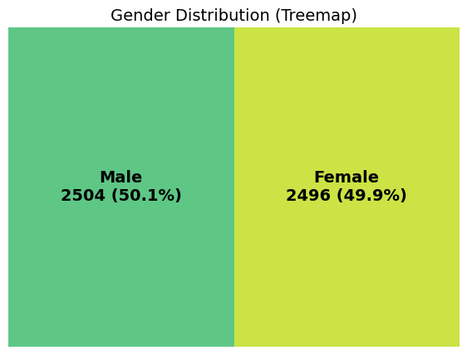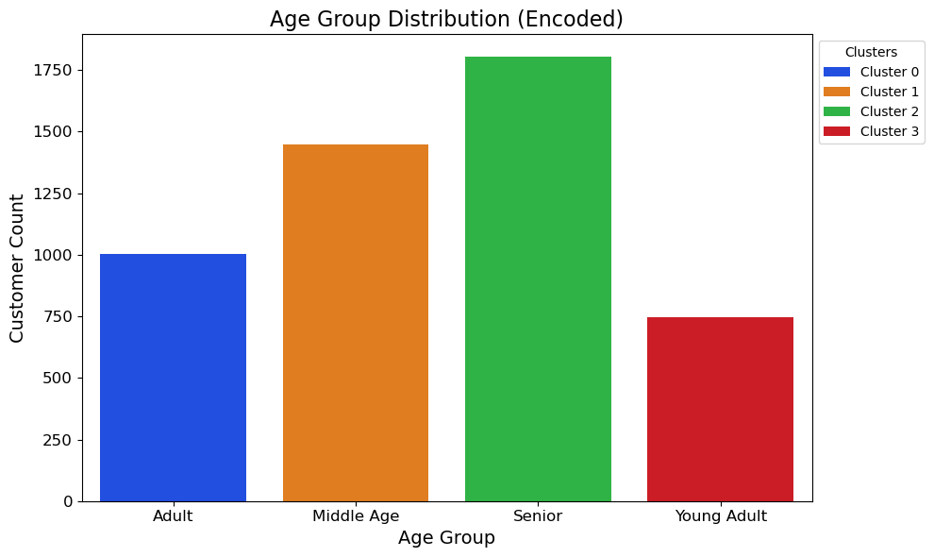
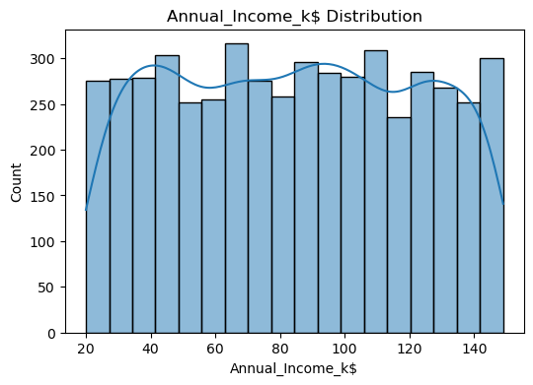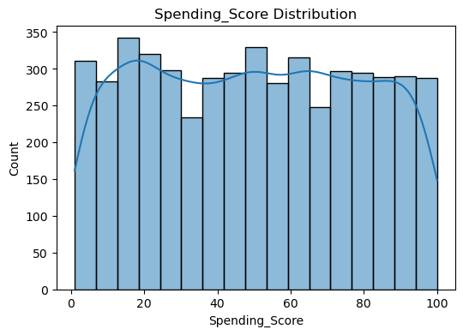
7. Elbow Method – Identifying the Ideal Number of Clusters
What the code does
- It runs K-Means for values of k = 2 to 10.
- For each value of k, it computes the Within Cluster Sum of Squares (WCSS).
- WCSS represents how tightly data points are grouped within each cluster.
- A lower WCSS means better-defined clusters.
Why this is needed
K-Means requires specifying the number of clusters before training.
The Elbow Method visualizes how clustering performance improves as k increases.
Logic used
- Initially, WCSS drops sharply as k increases.
- After a certain point, the rate of improvement slows significantly.
- This “bend” or “elbow” is the optimal number of clusters.

2️⃣ Automated Elbow Detection – KneeLocator
What KneeLocator does
- Instead of visually guessing the elbow point, you use the KneeLocator algorithm.
- It mathematically detects the point where the curve changes direction.
- This is more accurate and repeatable than manual selection.
Logic used
- curve='convex' → because WCSS curve looks convex.
- direction='decreasing' → WCSS always decreases as k increases.
- It returns the optimal elbow_k.

3️⃣ Plotting the Elbow Curve
What the plot shows
- A line graph of k vs WCSS.
- A red marker highlights the computed optimal number of clusters.
- This makes it easy to present and justify cluster selection.
Interpretation
If the elbow_k = 4 (as seen in your earlier plot), it means:
“Using 4 clusters gives the best balance between accuracy and simplicity.”

📌 Summary for Project Report
Here is the exact paragraph you can use in your report:
“To determine the optimal number of clusters, K-Means was trained for k values ranging from 2 to 10, and the Within-Cluster Sum of Squares (WCSS) was computed for each. The Elbow Method was applied to visualize the reduction in WCSS as k increased. To automate elbow detection, the KneeLocator algorithm was used, which identified k = 4 as the optimal value. This indicates that four clusters provide the best balance between compactness and interpretability of customer segments.”
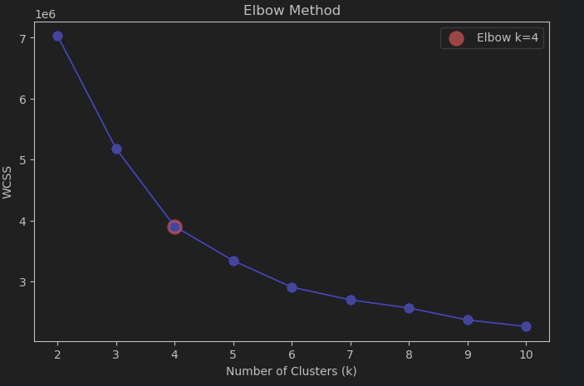
Silhouette Score Analysis – Optimal Cluster Evaluation
The Silhouette Score measures how well each point fits into its assigned cluster compared to other clusters.
It ranges from -1 to +1, where:
- Closer to +1 → well-separated, compact clusters
- Around 0 → overlapping clusters
- Negative → likely wrongly assigned clusters

1️⃣ What the Code Does
- Runs K-Means for values of k = 2 to 10.
- Computes the Silhouette Score for each k.
- Identifies the k with the highest silhouette score.
- Plots all scores and marks the best cluster count with a green highlight.

2️⃣ Interpretation of the Silhouette Plot
🔍 Observations from the Graph
- The highest silhouette score occurs at k = 2, approximately 0.36.
- As k increases, the silhouette score steadily decreases, showing:
  - Clusters become less distinct.
  - Separation between clusters weakens.
  - Compactness reduces.
✔️ Optimal Number of Clusters According to Silhouette Method
- k = 2 is mathematically the best clustering solution based on silhouette score.
- This indicates that two well-separated customer groups exist at the broadest level.
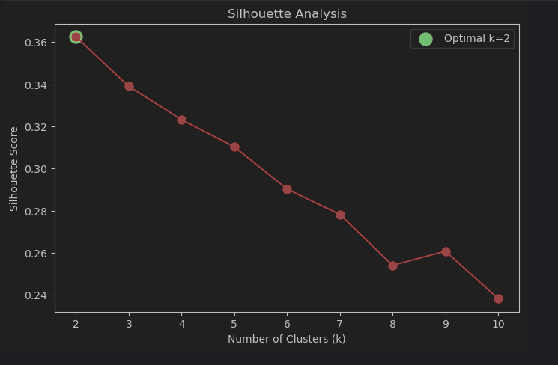
COMPARISON:K -MEANS VS GMM CLUSTERING
K-Means is a simple and fast clustering method that groups data based on distance to the nearest centroid. It works best when clusters are clearly separated and spherical in shape. However, it assigns each data point to only one cluster, which is a limitation when clusters overlap.
On the other hand, Gaussian Mixture Model (GMM) uses a probability-based approach, allowing soft clustering where each point can belong to multiple clusters with certain probabilities. GMM handles complex and overlapping cluster shapes better than K-Means. Overall, K-Means is efficient, while GMM is more flexible and accurate for irregular data patterns.
K-Means Clusters in 3D PCA Space
3D PCA Cluster Visualization – Analysis & Interpretation
This plot represents the K-Means customer clusters projected into 3 principal components (PCA1, PCA2, PCA3), enabling a visual understanding of how the four clusters are distributed in reduced feature space.

1️⃣ What the Visualization Shows
✔ Dimensionality Reduction using PCA
- High-dimensional customer features were reduced to 3 principal components.
- PCA retains the maximum possible variance while making visualization feasible.
✔ Cluster Representation
Each color represents one of the four K-Means clusters:
Cluster | Color | Sample Count
Cluster 1 | Blue | 1297
Cluster 3 | Orange | 1279
Cluster 2 | Green | 1232
Cluster 0 | Red | 1192
The counts show clusters are fairly balanced, meaning the K-Means algorithm successfully created groups of similar size — validating good cluster distribution.

2️⃣ Interpretation of the Cluster Structure
🔹 Clear Separation in PCA Space
- The clusters occupy distinct but partially overlapping regions.
- This indicates:
  - Customers form meaningful, natural groupings.
  - Some overlap is expected, since PCA compresses data and some features may share patterns.
🔹 Cluster Compactness
- Clusters appear reasonably tight, suggesting:
  - Good intra-cluster homogeneity (customers inside the same cluster behave similarly).
  - Moderate inter-cluster separation (clusters differ meaningfully).
🔹 PCA Component Influence
- PCA1 captures the largest variance — visible spread across the X-axis.
- PCA2 and PCA3 help distinguish secondary variations in customer behavior.

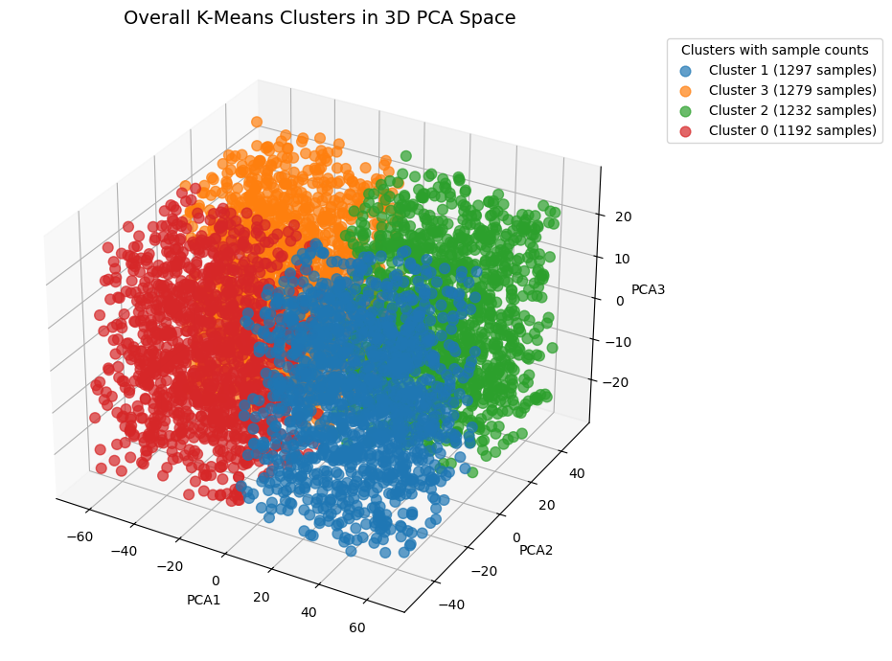
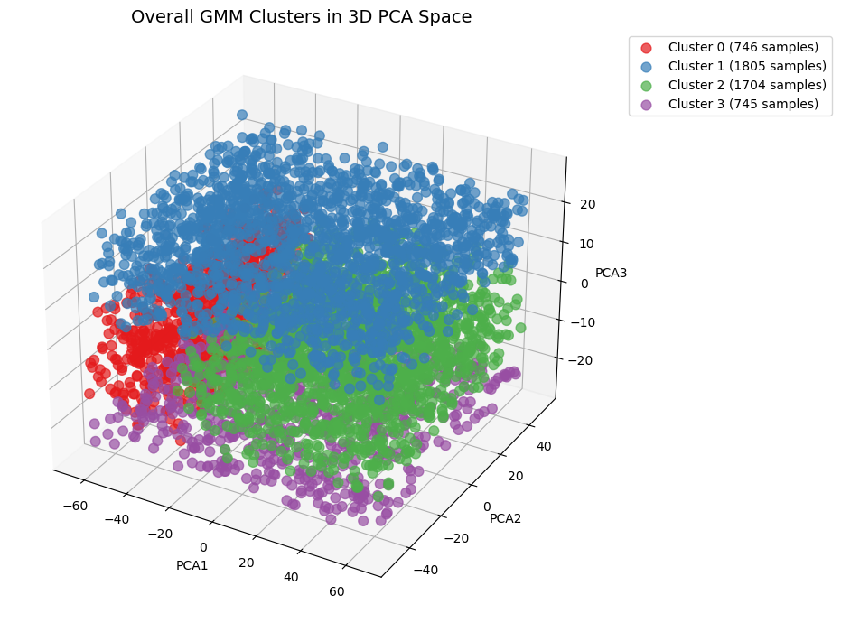
GMM CLUSTERS IN 3D PCA SPACE
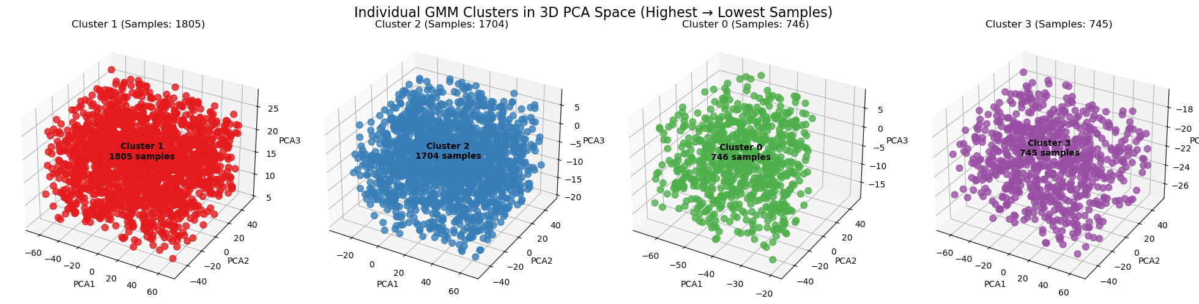
COMPARISON :K-MEANS VS GMM CLUSTERING

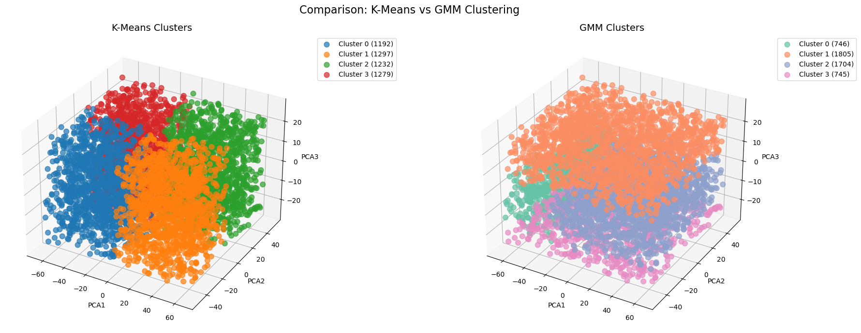

8.CLUSTERING APPROACH (K-MEANS)
To find how many customer groups (clusters) best fit the data, two The Silhouette Score measures how well each point fits within its assigned cluster compared to other clusters.
- The score ranges from -1 to 1, where values closer to 1 indicate well-separated and well-defined clusters.
- The highest silhouette score occurs around k = 5, showing that customer groups are most clearly separated at this cluster.
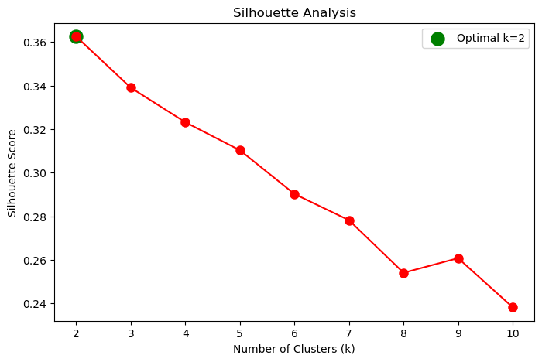

- High-spending customers are usually younger and fall into either low-income or high-income groups.
- Middle-aged customers generally show average or low spending habits.
- Gender does not affect how much customers earn or spend.
- Customers form clear groups based on their income and spending score, which makes clustering effective.
10.SUPPORTING VISUALS
For Gender Distribution
TREEMAP

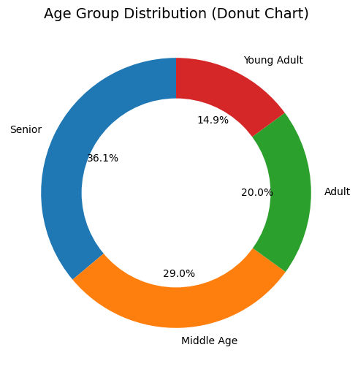
DONUT CHART
For Age Distribution

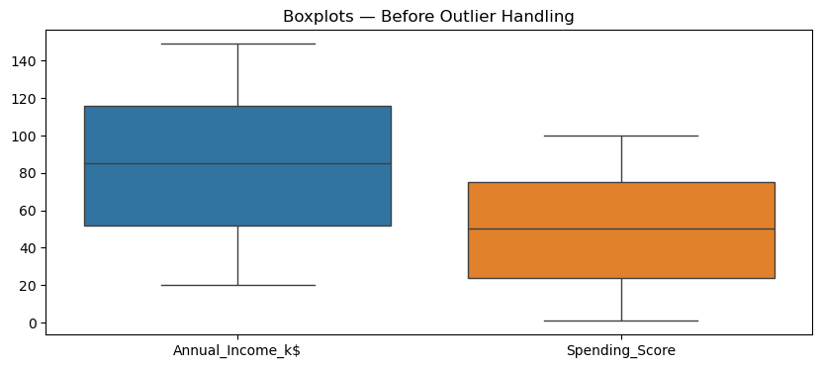
For Income vs Spending
BOXPLOT
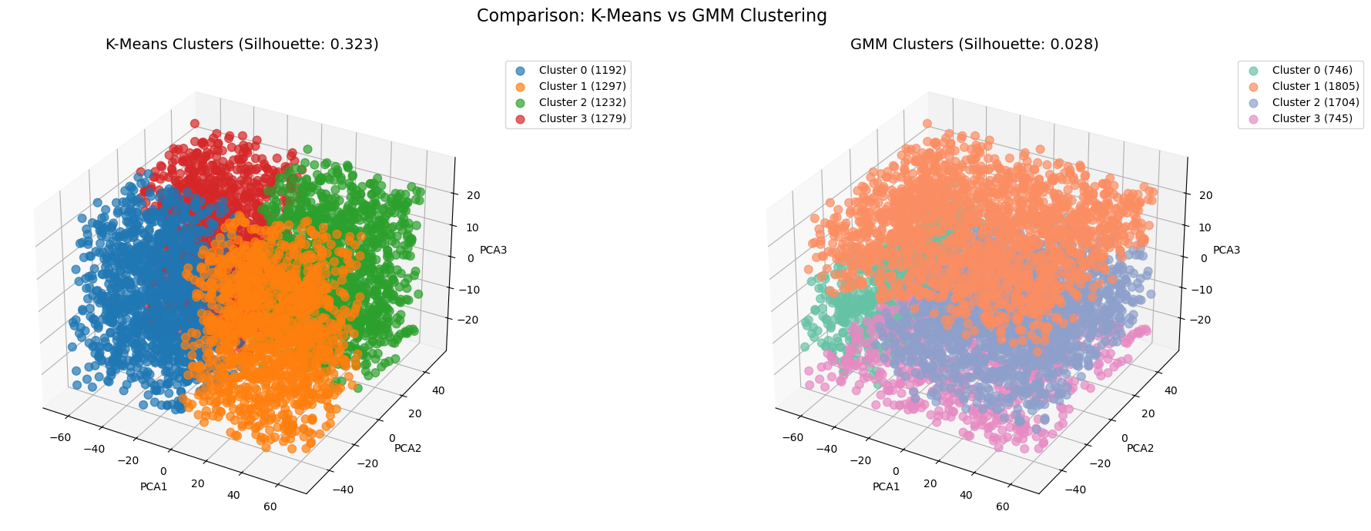
SCATTER PLOT

For K-Means vs GMM Clustering
11.LIMITATIONS
* The dataset contains limited features, restricting deeper analysis of customer behavior.
* K-Means assumes spherical and equally sized clusters, which may not reflect real-world patterns.
* Outliers can distort the cluster centers and reduce model accuracy.
* Customer behavior can change over time, making static clustering less reliable without regular updates.

12.RECOMMENDATIONS
• Add more customer attributes (purchase history, visit frequency, preferences) to improve segmentation accuracy.
• Validate the clusters with business or marketing teams to ensure they match real customer behavior.
• Explore advanced clustering methods like GMM or DBSCAN for more flexible and accurate grouping.

13.CONCLUSION
This project effectively segmented mall customers using clustering techniques, revealing clear patterns in income and spending behavior. K-Means successfully formed meaningful customer groups that help understand different shopping habits. These insights support better-targeted marketing strategies and improved customer engagement. Overall, the analysis provides a strong foundation for data-driven decision-making in mall management.

